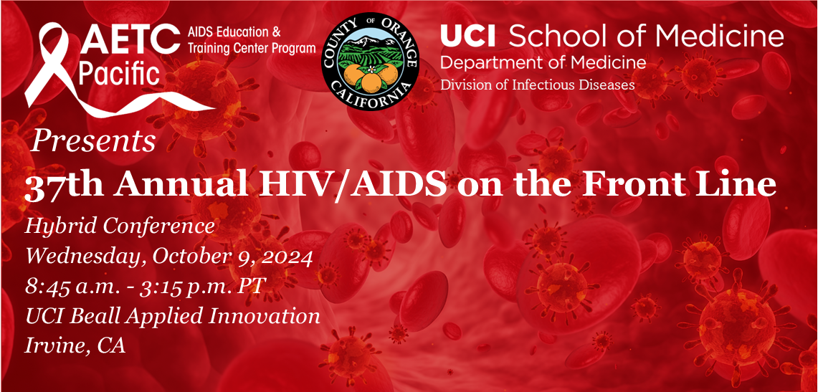

**Purpose**

The purpose of this conference is to provide healthcare professionals the opportunity to enhance their knowledge and treatment skills with new and updated data for people with HIV or at risk for HIV. The sessions will be presented by practicing experts and based upon the latest state-of-the-art research of HIV therapy and care. The information presented will enhance compassionate caring skills and provide information that will support the diagnosis, treatment, and prevention of HIV. Cultural and societal issues that directly impact HIV care and prevention will be presented. At the end of this conference, it is expected that the participants will have an up-to-date understanding of the best clinical approaches for HIV treatment and prevention.

**Target Audience**

This conference was developed for MDs, RNs, ID Specialists, PAs, NPs, Psychiatrists, MFTs, LCSWs, Pharmacists, Substance Abuse Professionals, Case Managers, Pediatric ID Specialists, and other healthcare workers who support HIV care and prevention.

**Learning Objectives**

At the conclusion of this conference, the participants will be able to:

* Describe new and current advances in antiviral treatment for the care and prevention of individuals living with, or at risk, for HIV.
* Recognize and address issues that affect the aging cohort of individuals living

with HIV such as cardiovascular disease, mental health, and drug use.

* Recognize and address emerging issues in sexually transmitted infections.

***For more information go to the*** [***conference website***](http://www.hivconference.org/) ***(www.hivconference.org)***

**Accreditation Statement**

The University of California, Irvine School of Medicine is accredited by the Accreditation Council for Continuing Medical Education to provide continuing medical education for physicians.

**Designation Statement**

The University of California, Irvine School of Medicine designates this live activity for a maximum of *5.25 AMA PRA Category 1 Credits™*. Participants should claim only the credit commensurate with the extent of their participation in the activity.

A non-physician Healthcare Professional certificate of attendance for CEU purposes will be provided. Non-physicians may submit the HP certificate to their own credentialing board (nursing, pharmacy, social work, etc.) to see if they can obtain transferrable CEU’s.

**General Disclosure Statement**

It is the policy of the University of California, Irvine School of Medicine to ensure balance, independence, objectivity, and scientific rigor in all educational activities. The views and opinions expressed in this activity are those of the speakers and do not necessarily reflect the views of the University of California, Irvine School of Medicine. Full disclosure will be included during the conference presentation and listed on the [conference website](http://www.hivconference.org/) ([www.hivconference.org](http://www.hivconference.org)) or [37th Annual HIV/AIDS on the Front Line Conference](https://uci.cloud-cme.com/course/courseoverview?P=0&EID=1161).

University of California, Irvine School of Medicine Continuing Medical Education adheres to the ACCME’s Standards for Integrity and Independence in Accredited Continuing Education. Any individuals in a position to control the content of a CE activity, including faculty, planners, reviewers or others are required to disclose all relevant financial relationships with ineligible entities (commercial interests). All relevant conflicts of interest have been mitigated prior to the commencement of the activity.

**ADA Statement**

In compliance with the Americans with Disabilities Act, we will make every reasonable effort to accommodate your needs. For any special requests, please call (714) 456-6871.

**California Assembly Bill 1195 and 241**

This activity is in compliance with California Assembly Bill 1195 and 241, which require CME activities with patient care components to include curriculum in the subjects of cultural and linguistic competency & implicit bias. It is the intent of AB 1195 and AB 241 to encourage physicians and surgeons, CME providers in the State of California, and the Accreditation Council for Continuing Medical Education to meet the cultural and linguistic concerns of a diverse patient population and reduce health disparities through appropriate professional development. Please see the CME website, [www.meded.uci.edu/cme](http://www.meded.uci.edu/cme), for AB 1195 and AB 241 resources.

**Pacific AETC**

The Pacific AIDS Education & Training Center (Pacific AETC) is supported by the Health Resources and Services Administration (HRSA) of the U.S. Department of Health and Human Services (HHS) as part of an award totaling $4,305,236. The contents are those of the author(s) and do not necessarily represent the official views of, nor an endorsement, by HRSA, HHS, or the U.S. Government. For more information, please visit [HRSA.gov](https://www.hrsa.gov/).

**REGISTRATION & PROGRAM**

|  |  |
| --- | --- |
| **Virtual Registration Fee** | **In-Person Registration Fees** |
| * Free | * $50 – General (Healthcare Providers, Public Health, Nonprofit Organizations) * $25 – Medical Students / Residents/ Fellows * $100 – Sales / Non-Healthcare Employees of For-Profit Industry   In-Person registration fee includes light refreshments, lunch, and CME certificate. |



[**Registration:**](https://hivconference.org/registration/) **https://rb.gy/8pj2kk**

**8:45 A.M. Welcome and Introductions**

Geeta Gupta, MD

Director

Pacific AIDS Education & Training Center – Orange County & Inland Empire

University of California, Irvine, Division of Infectious Diseases

**9:00 A.M. STI Update**

**Kelly Johnson, MD, MPH**

Medical Director, California STI/HIV Prevention Training Center

Assistant Professor of Medicine, UCSF Division of Infectious Diseases

Public Health Medical Officer, STD Control Branch, California Department of Public Health

**9:50 A.M. Q&A Session**

**10:00 A.M. Cardiovascular Disease Prevention for People with HIV: Implications of**

**the REPRIEVE Trial**

**Steven Grinspoon, MD**

Professor of Medicine

Chief, Metabolism Unit and Endowed Chair

Mass General Hospital and Harvard Medical School

**10:45 A.M. Q&A Session**

**10:55 A.M.** **BREAK**

**11:10 A.M. HIV & PrEP Update**

**Paul E. Sax, MD**

Clinical Director, Division of Infectious Diseases

Brigham and Women's Hospital

Professor of Medicine

Harvard Medical School

**12:05 P.M. Q&A Session**

**12:15 P.M.** **LUNCH**

**1:15 P.M. Injectable Antiretroviral Therapy: This Might Hurt a Little Bit**

**Catherine Diamond, MD, MPH**

Clinical Professor

Pacific AIDS Education & Training Center – Orange County & Inland Empire

University of California, Irvine, Division of Infectious Diseases

**Lucas Hill, PharmD, AAHIVP**

HIV Pharmacist Specialist

UC San Diego Owen Clinic

**2:05 P.M. Q&A Session**

**2:10 P.M. Mental Health and Substance Use in the Aging HIV Population**

**Lawrence McGlynn, MD**

Clinical Professor, Psychiatry & Behavioral Sciences – Medical Psychiatry  
 Positive Care Clinic

Stanford University

**3:00 P.M. Q&A Session**

**3:10 P.M. Closing Remarks**

